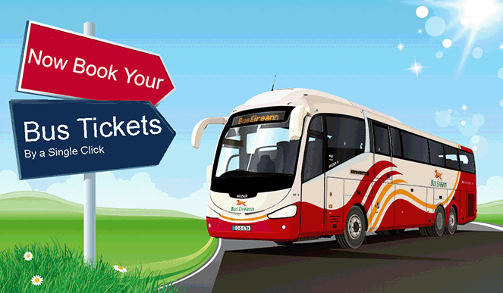

Software Requirements Specification

For online bus ticket booking

Version 1.0

|  |  |
| --- | --- |
| 140011X | H.M.A. Abeywardana |
| 140014J | U.M.J. Abeywikrama |
| 140024N | P.T. Amarasinghe |
| 140323F | R.P.D. Kumarasinghe |

Table of Contents

1. Introduction 3

1.1 Purpose 3

1.2 Scope 3

1.3 Definitions, Acronyms, and Abbreviations 3

1.4 References 4

1.5 Overview 4

2. Overall Description 4

2.1 Product perspective: 4

2.2 Product functions: 4

2.3 Product characteristics: 5

2.4 Constraints: 5

2.5 Assumptions and dependencies: 5

3. Specific Requirements 5

3.1 Functionality 5

3.1.1 Bus owner 5

3.1.2 Passenger 6

3.1.3 Operator 6

3.1.4 National Transport Commission (NTC) 7

3.2 Non Functional Requirements 7

3.2.1 Security 7

3.2.2 Reliability 8

3.2.3 Availability 8

3.2.4 Maintainability 8

3.2.5 Supportability 8

3.3 Story of the process 8

3.4 Design Constraints 8

3.5 Assumptions 9

3.6 Technologies 9

4. Supporting Information 9

4.1 User Interface prototypes 9

4.1.1 Customer 9

4.2.2 Bus Operator 11

4.1.2 NTC 12

Software Requirements Specification

# Introduction

Introduction section provides a description of everything included in this SRS document. Purpose, Scope, Abbreviations and overview is included in this section needed for referring this document.

## Purpose

Purpose of this document is provide a reference to developers describing about “ticketing.lk” web application. This will describe the all details need to know about requirements, system constraints of this ticketing web application.

## Scope

NTC will introduce a new software for online ticket booking for long distance travelling busses. This project will facilitate passengers to book seats online and search bus available times for required route. Passengers can search busses for category they prefer. Also they have a chance to cancel their booking, 24 hours before the journey.

Passenger will get a sms or email after online payment. For manual booking passengers they will receive a ticket after handing over money to the operator. NTC will have the authority to add new routes, busses to the system and add changes to the bus schedule. Bus operators will have facility for both manual and online booking. So they have the functionality to modify number of seats available for online booking. The project will be completed by mid of December 2016.

## Definitions, Acronyms, and Abbreviations

|  |  |
| --- | --- |
| Term | Definition |
| Passenger | Person who needs a booking |
| Operator | Person who controls the buses in the bus stand and issue the tickets to booked customers. |
| Bus owner | A company or a person who wants to register a bus in the system |
| NTC | National Transport Commission |
| Journey verification | Verify the bus has leave and finished the journey |
| System | All the components included processing and storing data in booking.lk |
| Application | Booking.lk system software |

## References

##### <http://www.ntc.gov.lk/>

* <http://www.rda.gov.lk/source/rda_roads.htm>

## Overview

The document contains four sections and 1st section provides the introduction to this document. Rest of the part in this is describing about the application details.

2nd section provides a description on general factors that affect on ticketing.lk and its requirements. In this section it tries to give an idea about those things that has fully described in section 3 to get easier the understanding.

In section 3 it is presented the most important part of this document. There all the requirements have been described with full details. It contains function requirements, non-functional requirements. Also it describes the constraints of the system.   
also the technologies we are going to use here is described in section 3.

Section 4 describes the supporting information including user interfaces and other supporting stuff.

# Overall Description

This section describes the background and general factors that affect the final product.

## Product perspective:

Bus Owner should be able to register to get the service and it can be done manually or online. Customers can book seats from the online service. Both manual and online applications are connected to the same database server. So every update in the booking system can be accessed by every user instantly.

## Product functions:

Bus owners can register their buses in the system and they can modify details later. Customers can search and select their route and get daily schedule and book seats as they desire. Only credit card payments are available through this application.

## Product characteristics:

This application gives access to three main users: Bus owner, Customer, bus operator and Administrator. They have different access levels to the system since they have different uses from the application.

Bus operator or owner can add basic details about the bus such as no of seats, route number, starting location and destination, license plate number, contact number, etc. And if there is a change he can modify it. But all the registrations and modifications need to be approved by the administrator.

Customer can input a starting point and destination to get available buses for a chosen day. Then they can select their choice and make the payment through a credit card. Then they will receive a message to their mobile phone and that will be used to verify the online ticket purchase when customer enter the bus.

## Constraints:

Cancellation of a booking should be done at least one hour before departing of the bus. Bus owners hasn’t any access to data. Users can’t book a bus for a journey which has lower cost than 100 rupees. There is a maximum number of seats which can be booked for one user. Online users can’t book seats without payment. Passengers cannot start the journey by intermediate stations.

## Assumptions and dependencies:

We should assume that database server will work well without unintentional failures which might cause sudden failures of the system.

# Specific Requirements

Here this section contains a full description of system functionality, design constraints, assumptions and technologies.

## Functionality

Functionalities are described here under 4 main categories. They are Bus owner, Passenger, Bus operator and NTC (National Transportation Commission).

### Bus owner

#### register a bus for online booking system.

This is for new owners who need to add the add their bus to the system. They fill a forum and it is sent to the NTC admin. He approves it.

### Passenger

#### Observe time table

Passengers should be able to get the time table of the busses for their journey. For that they are able to filter the time table by entering starting point and the destination with required date. Then the system is providing list of the suitable buses with their details.

Details are contained: bus’s starting and end points, bus number, category (semi luxury, luxury, normal …)

#### Make a booking

After getting the time table passengers should be able to book a bus on a specific date. It is done by selecting a bus from the table he got from time table searching.

Then he should fill the forum for booking. Forum should be filled by name, Id, phone number, number of passengers, seat numbers that he needs to book and paying details.

This should be done by 2 ways. Either online or offline.

* Online: Passenger going through booking.lk website.
* Offline: Passenger meets a bus operator at a bus station and ask him to book. Here the operator is doing the same thing that passenger doing online.

Bus charges are going to the NTC account temporary until the journey is completed.

*Passenger is getting a key code for their booking. And it is necessary for getting the bus ticket.

#### Cancel a booking

Passengers can cancel a booking by informing the operator or online by cancel booking option.

### Operator

#### Make a booking

Bus operator has the ability to make a booking on behalf of the passenger. He can take details of the passenger and make the booking. Passenger will hand over money to the operator and he will add these details to the system.

#### Verify a booking

Operator has the facility to check whether a specific customer has made a booking or not. This will need when online booker ask for the ticket from the operator office.

#### Print the ticket

Operator has the facility to print the ticket when passenger asks for the ticket. There are 2 cases. First case is passenger manually do a booking. So operator needs to give passenger the ticket. This functionality is related with the first functionality. Second case is online booker asks for the ticket. So operator need to verify the booking and print the ticket. This is related with the second functionality. Printed ticket will contain name of the passenger, seat number, bus number, date, time and about the journey.

#### Cancel a booking

Operator has the facility to cancel a booking, when a manual seat booker asks for a cancellation by attending to the operator office. Operator will update the system and cancel the booking.

#### Verify the journey

Operator has the functionality to conform that bus has leave the bus stand and bus has attend to the bus stand. This functionality is related to the functionality of NTC to distribute earnings to the specific bus owner or company.

### National Transport Commission (NTC)

#### Add new routes

Officer from NTC should be able to add a new route to the system. Route must contain details such as route number, time taken for transportation and start and end locations.

#### Add new busses

After owner requested for registering a new bus, NTC can do a background check and approve the request. If owner directly come to NTC and asked to register a bus, it can also be done after the investigation process.

#### Change routes

If the destinations of existing routes change, it can be modified in the system giving required information.

#### Change bus schedule

With the increase of the number of buses and routes or for a special day, bus routing schedule must be modified accordingly. This is modified manually by NTC.

#### Modify bus fare rates

Due to the changes in economic factors like rising oil price and vat changes bus fare should be updated accordingly.

#### Fund transferring

After completing a journey NTC is transferring the money to bus owner’s account for that journey bookings.

#### Fund transferring

After completing a journey NTC is transferring the money to bus owner’s account for that journey bookings.

## Non Functional Requirements

### Security

Through this system online money transaction will happen so security is important. Also this system contains valuable information so protection of that information is very important. Many people in the country will depend on this system so security of the system is important.

### Reliability

System should provide reliable information to its users. Every party involve with the system should has the trust about the system. System should not give any false information.

### Availability

System should be available in 24 hours. System cannot be stopped for a second. System should have the functionality to backup information in some sort of a trouble.

### Maintainability

System contains information about bus routes, busses and available times. This will expand with the time so system should be able to expand with the time. Also system should be able to easily maintain by users (especially by NTC).

### Supportability

System should support any type of hardware or operating system. As this is an online application system can be viewable from any kind of mobile or desktop devices. Also system should work in any type of internet browser.

## Story of the process

Here it is described the basic story of how a booking is happen with this system.

1. Passenger search for time table that suits with their journey. (Online method)
2. Passenger makes a booking. / operator make a booking for Passenger (Offline method). Fees that passengers paying is going to NTC account.
3. Passenger is getting the booking key. (by online email or written note from the operator in offline)
4. When the passenger is going their journey they can meet the operator at the bus stand and get their ticket from the operator by giving the key. (This can be done in the instance of booking in offline mode.)
5. Operator gives a note to the conductor have seats numbers with booked passenger’s id.
6. Conductor checks the seats with Passenger id.
7. After completing the journey bus owner is getting the bus fee for the bookings from NTC.

Done.

## Design Constraints

The bus ticket booking system is a web based application and it developed by using ‘PHP’, ‘Java Script’ and ‘HTML’ programming languages and ‘Materialize’ framework. The system use MySQL query language to manage databases. We use ‘NetBeans IDE’ as the development tools. The site is responsive with any device have web browsers.

## Assumptions

1. Assuming all the bus operators has capability to operate the system and has a computer in bus stands with internet.
2. Assume that every starting and end point bus station have operators.
3. If a bus is not available, it is replaced by another one.

## Technologies

For designing task we will use visual paradigm tool to draw entity relationship diagrams. For implementation we will use frameworks like materialize to produce html pages. Languages like pup and MySQL will also be used.

# Supporting Information

## User Interface prototypes

Here is showing several rough UI pages of the application. Those are shown by 3 kinds of users of the system. Passenger, Bus controller and NTC admin.

### Customer

#### 4.2.1.1 checking time table

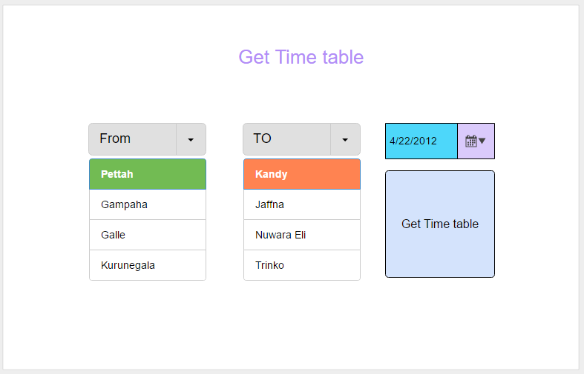

Figure -checking time table

#### 4.2.1.2 getting the time table and go to book

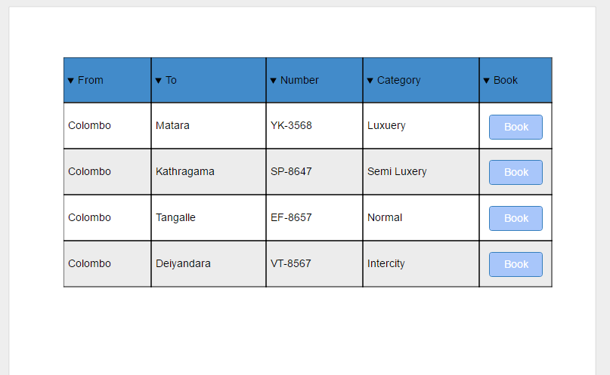

Figure -time table

#### 4.2.1.3 Booking a bus

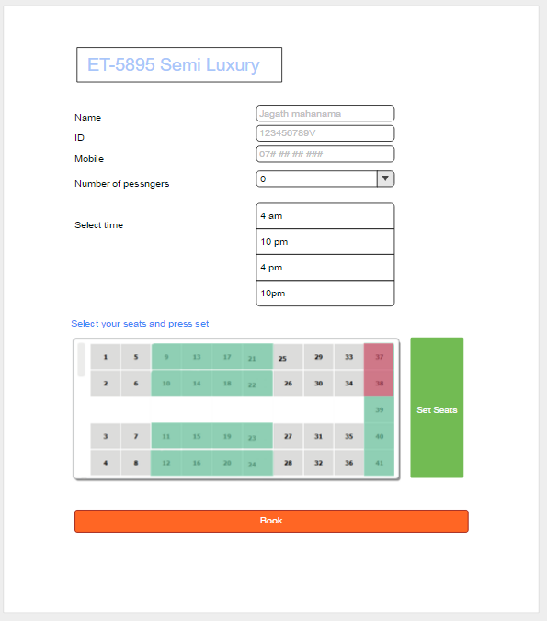

Figure -Add a booking

### 4.2.2 Bus Operator

#### 4.2.2.1 Checking bookings of busses

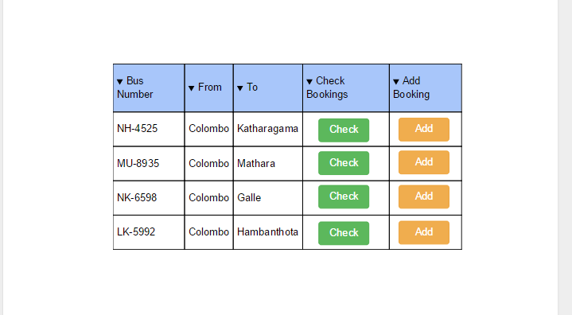

Figure - Checking bookings

#### 4.2.2.2 Issuing tickets and remove bookings

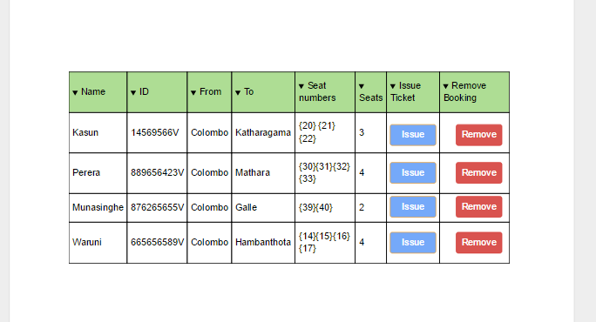

Figure - Ticket issueing

### NTC

#### 4.1.2.1 Main panel

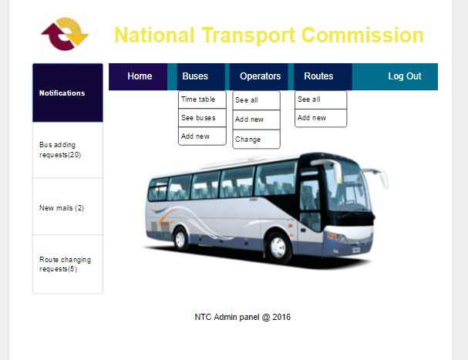

Figure -NTC Admin panel

…***…